**Project Name: Old Mates**

**Author: Andre Alexandrov**

**Date: 1/12/2023**

**Project Review**

**Time Management**

The estimating of a project schedule was quite accurate to what was done as there was some previous experience to go off when making the schedule for Old Mates. Regarding time management lessons where learnt on how to effectively finish tasks first that allow others to start on their tasks.

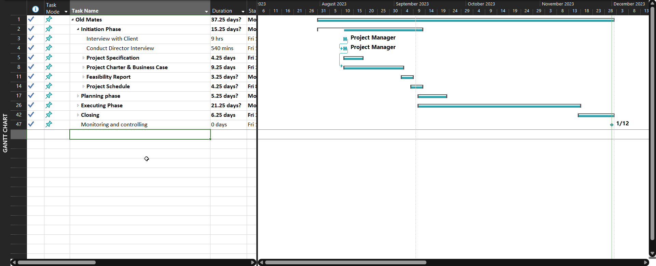

**Cost Management**

The estimated cost was accurate as all the tasks where completed on the respective due date meaning no extra costs where incurred but no savings where made either

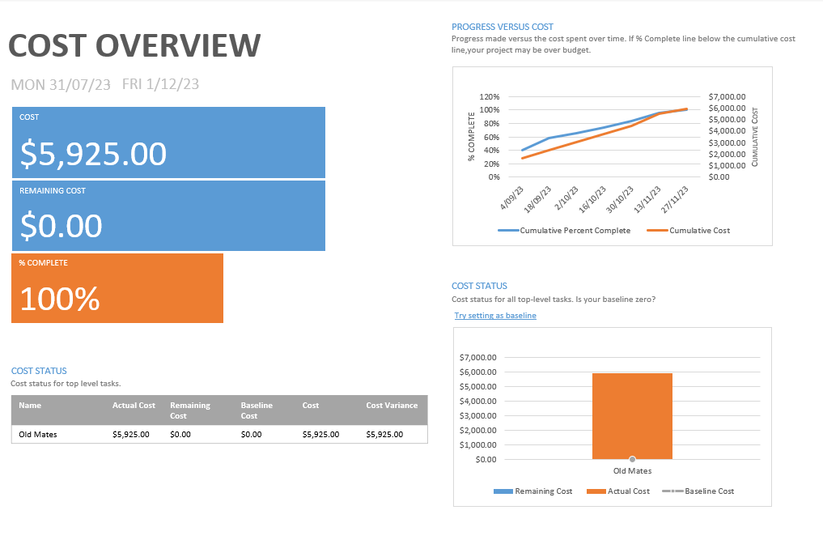

**Risk Management**

The risk management stargates where quite effective as every issue (mainly tasks falling behind) where addressed quickly and effectively, this was helped with previous experience on creating risk management plants/strategies, this taught me early identification of project risks and proactive mitigation/resolution

**Quality Management**

Testing was done thought the entire project whether done by running a mock-up of a site or using the console to see errors and troubleshooting. The project was also accepted by the client and handed over without issue. Some lessons learned for quality is how to effectively do troubleshooting and site testing, using built-in functions vs just displaying an error would have helped at the start, this is also an opportunity for improvement.